EV3 Taking Turns Quiz
Name:_________________________ Period:___ Date:________ Score:_____/30

Use the figure below to help answer the following questions
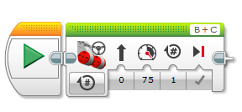

- (1 pts.) Is the above block a Move Steering Block and a Move Tank Block?

- (2 pts.) What is the difference between a Move Steering Block and a Move Tank Block?

- (2 pts.) What is a Turn in Place turn and how do you implement one with Move Steering Blocks?

- (2 pts.) What is a Swing Wide Turn and how do you implement one with Move Steering Blocks?
- (2 pts.) What is a U-turn and how do you implement one with Move Steering Blocks?
- (2 pts.) Ziffle writes a program to have his robot make a 90 degree point turn to the right. Ziffle sets all the Move Steering Block parameters properly to make a right turn and sets the Duration parameter to 90 degrees. Ziffle is disappointed to discover that his robot only turns about 60 degrees. Why did Ziffle not get the expected result?
- (3 pts.) Describe three methods Ziffle could use to determine the correct parameters for the Move Steering Block in question 6.

- (4 pts.) What is “Overturning”?

- (3 pts) List 3 things that can cause “Overturning”.

- (2pts) List 2 possible ways to compensate for “Overturning”.

- (2 pts) If you want the robot to turn closer to 90 degrees, what 2 changes would you make to this program?
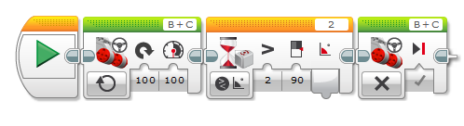

- (5 pts)Write the Pseudocode for the following program. 